Programming Assignment 4

Test Data

Neha Prasad | CS-450 | Grp15

Azhar Shaikh | CS-450 | Grp15

# Prog 1 : directoryWalker

* Initially prints all files and directories names, inode number and type associated with them from the Xv6 root.

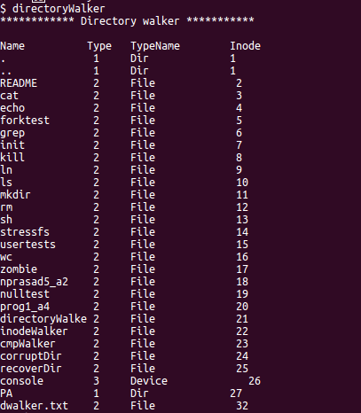

* Starting from specified location.

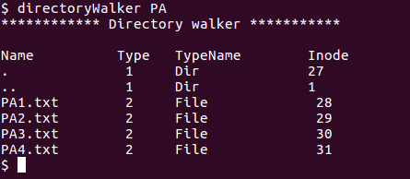

## Prog 2 : inodeWalker

Prints out all the allocated inodes in the Xv6 file system.

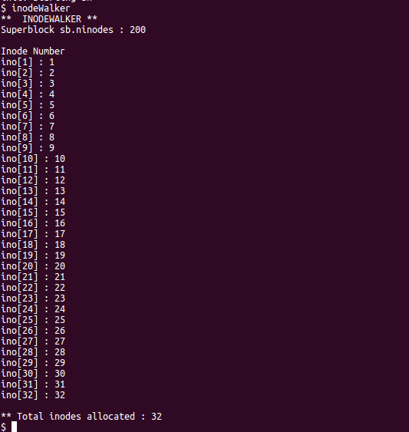

## Prog 3 : compareWalker

Compares the inodes returned by the above two programs.

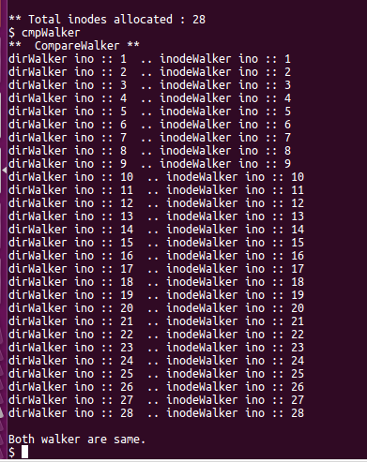

## Prog 4 : corruptDir

When corruptDir program is executed it will corrupt the specified directory file size and make it and its content inaccessible.

Directory accessible before running corruptDir file

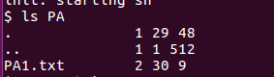

Making the directory file corrupt by corrupting its size

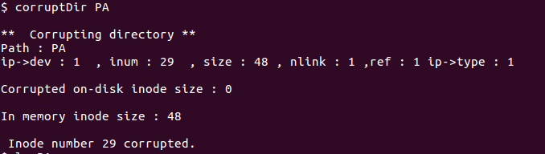

Directory Inaccessible after running corruptDir file

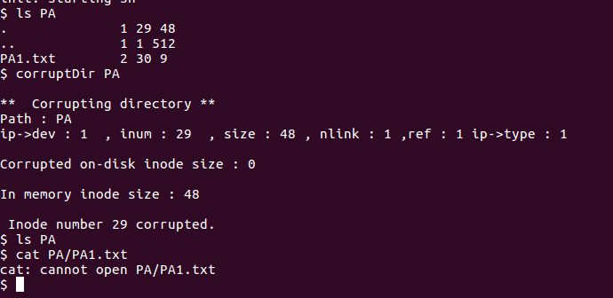

## Prog 5 : recoverDir

When recoverDir program is executed it will recover the specified directory file’s correct size which was corrupted by the corruptDir program and will make it and its content accessible again.

